Exact auth flow: “authenticate once → save state → reuse state”
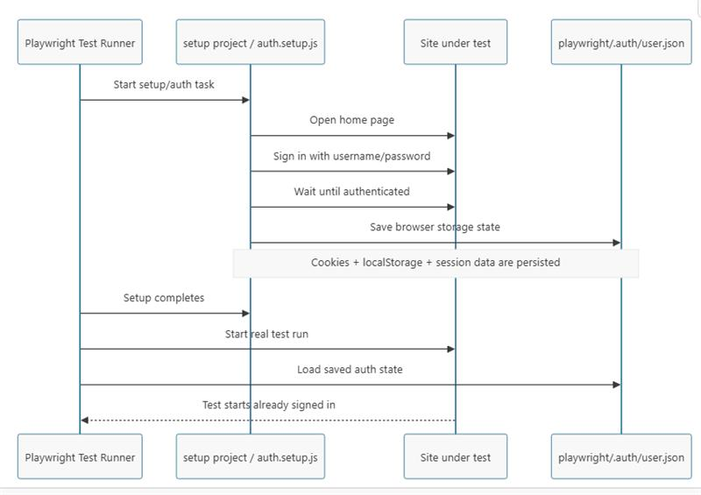
The intended pattern in this repo is exactly this:
- playwright.config.js defines the storage path:
export const STORAGE_STATE = path.join(__dirname, 'playwright/.auth/user.json');
- tests/auth.setup.js is the setup step that should:
  - open the app
  - sign in
  - save the browser state with page.context().storageState({ path: STORAGE_STATE })
- Later, tests can reuse that saved state instead of logging in again
This is the normal Playwright approach for global auth.

and use it in spec files as ,
test.use({
storageState : 'playwright/.auth/user.json'
});

if you dont need the saved auth the u can use if the testcase requires specific user login
page = await login('TestUsers', 1)

This method:
- creates a browser
- opens the app
- clicks Sign In
- fills username/password
- submits login
- verifies user is logged in
How do you handle authentication globally to avoid logging into the UI before every single test case?
- Answer: You implement the Storage State pattern to save and reuse authentication states.
- "To avoid logging in before every test, I use Playwright's storageState. I authenticate once in a setup script, save cookies and session data to a JSON file, and reuse that state across all tests, which improves execution speed and test stability."

Run Auth Setup Once
↓
Save cookies/session/local storage
↓
user.json created
↓
All tests reuse user.json
↓
Already logged in

- Create an authentication setup test that logs into the application once using credentials.
Step 1: Create an Authentication Setup Script

import { test as setup } from '@playwright/test';

setup('Authenticate', async ({ page }) => {
await page.goto('https://app.example.com/login');

await page.fill('#username', 'testuser');
await page.fill('#password', 'password');

await page.click('button[type="submit"]');

await page.context().storageState({
path: 'playwright/.auth/user.json'
});
//Capture the authenticated state (cookies, tokens, and storage) in user.json
});

- Configure playwright.config.ts to inject this global storageState path into all regular test projects, pre-authenticating them instantly before the page even loads.
Step 2: Configure Playwright

import { defineConfig } from '@playwright/test';

export default defineConfig({
use: {
storageState: 'playwright/.auth/user.json'
}
});

Step 3: Use Directly in Tests

test('Verify dashboard', async ({ page }) => {
await page.goto('/dashboard');

await expect(page.locator('h1')).toContainText('Dashboard');
});
//No login step is required because Playwright loads the saved authentication state automatically.

Follow-up Interview Question
Q: Why use storageState instead of beforeEach() login?
Answer: beforeEach() performs login for every test execution, making the suite slow and more prone to UI-related failures. storageState authenticates once and reuses the session, resulting in faster and more reliable test execution.

Yes, we can use beforeAll() to log in once and save the authentication state. However, for scalable Playwright frameworks, I prefer using a dedicated authentication setup that generates a storageState file and reuses it across all tests. This works better with parallel execution and is the Playwright-recommended approach.

